**Summary:**

## **The beauty of dashboards**

Dashboards are powerful visual tools that help you tell your data story. A **dashboard** organizes information from multiple datasets into one central location, offering huge time-savings.

Data analysts use dashboards to track, analyze, and visualize data in order to answer questions and solve problems.

The following table summarizes the benefits of using a dashboard for both data analysts and their stakeholders.

| **Benefits** | **For Data Analysts** | **For Stakeholders** |
| --- | --- | --- |
| **Centralization** | Sharing a single source of data with all stakeholders | Working with a comprehensive view of data, initiatives, objectives, projects, processes, and more |
| **Visualization** | Showing and updating live, incoming data in real time* | Spotting changing trends and patterns more quickly |
| **Insightfulness** | Pulling relevant information from different datasets | Understanding the story behind the numbers to keep track of goals and make data-driven decisions |
| **Customization** | Creating custom views dedicated to a specific person, project, or presentation of the data | Drilling down to more specific areas of specialized interest or concern |

## 

## **Creating a dashboard**

Here is a process you can follow to create a dashboard:

**1.** **Identify the stakeholders who need to see the data and how they will use it**

**2. Design the dashboard (what should be displayed)**

**3. Create mock-ups if desired**

**4. Select the visualizations you will use on the dashboard**

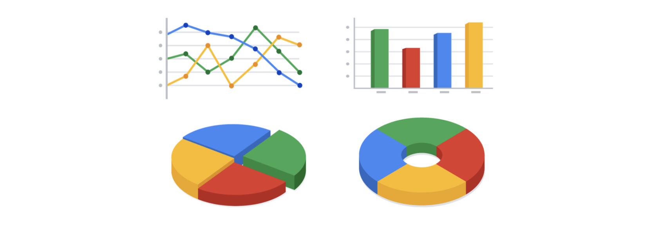

**5.** **Create filters as needed**

## 

## 

## 

## 

## **Types of dashboards**



* **Strategic:** *focuses on long term goals and strategies at the highest level of metrics*

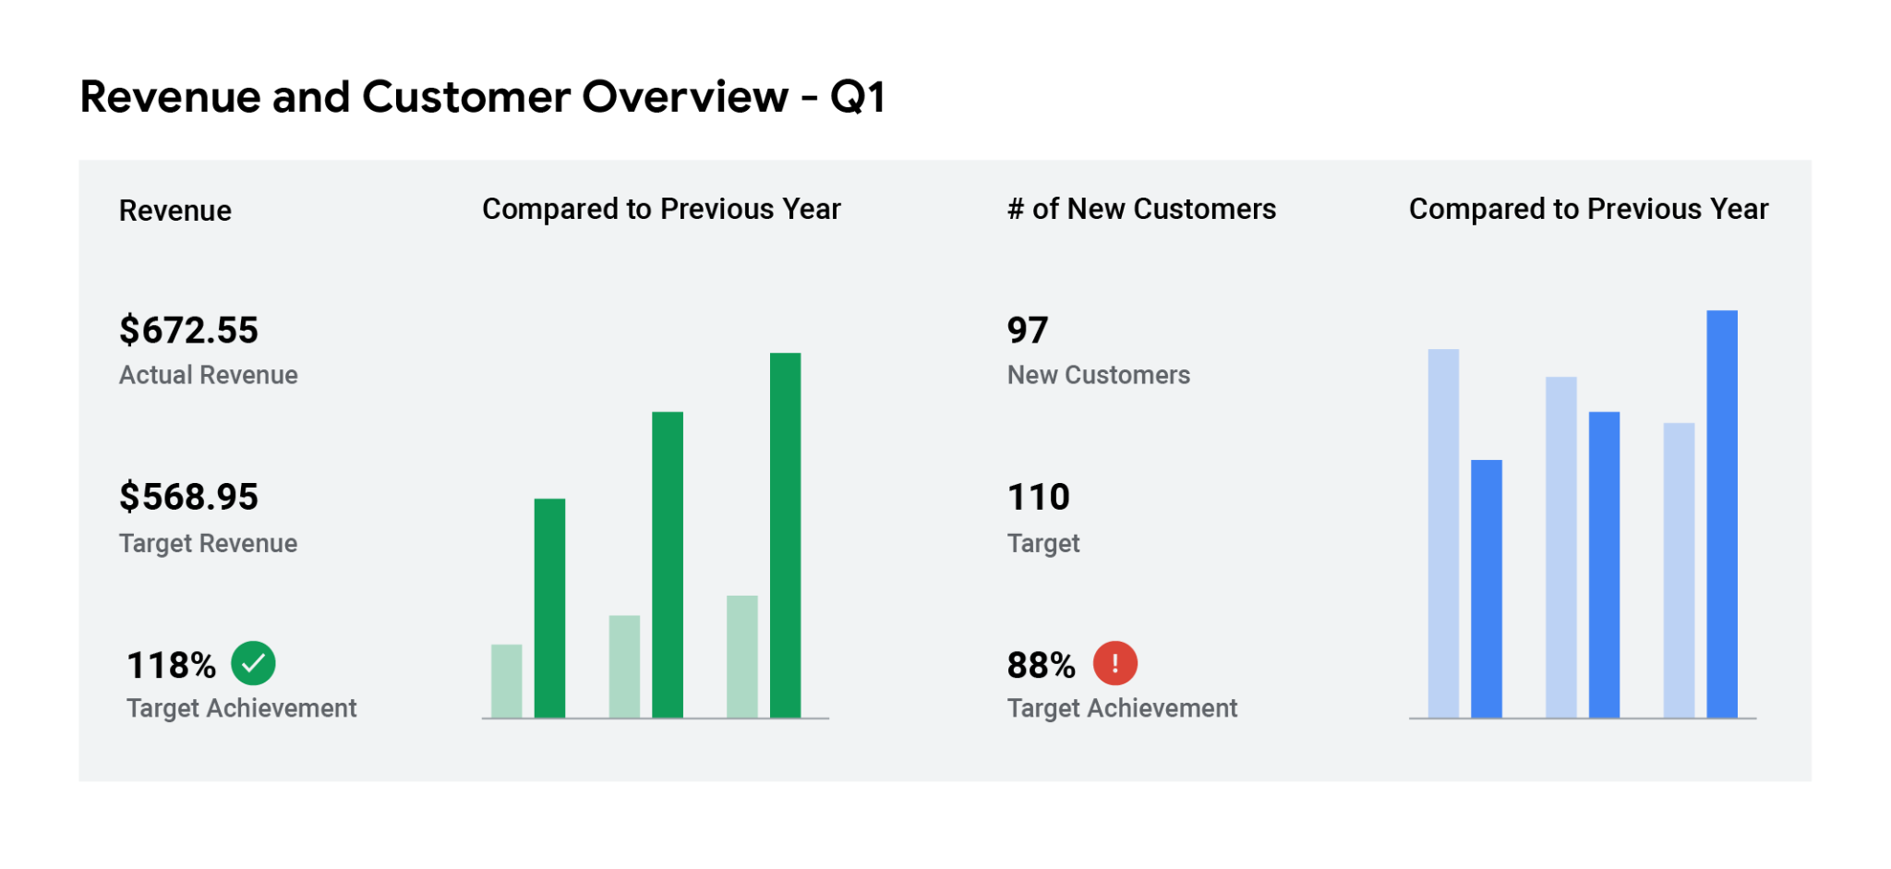

* **Operational:** *short-term performance tracking and intermediate goals*

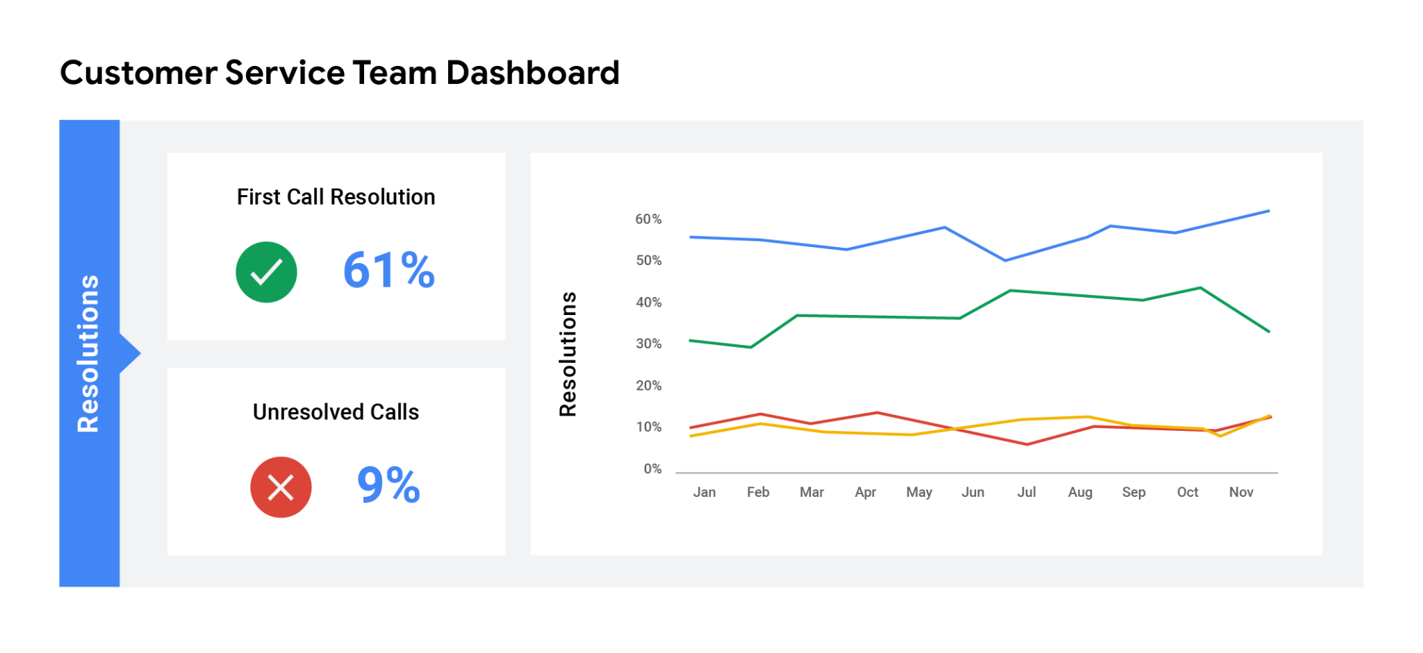

* **Analytical:** *consists of the datasets and the mathematics used in these sets*

